**Task 1: ( 15 Basic Git Commands ):**

1. **git status :**

This is used check the git status.

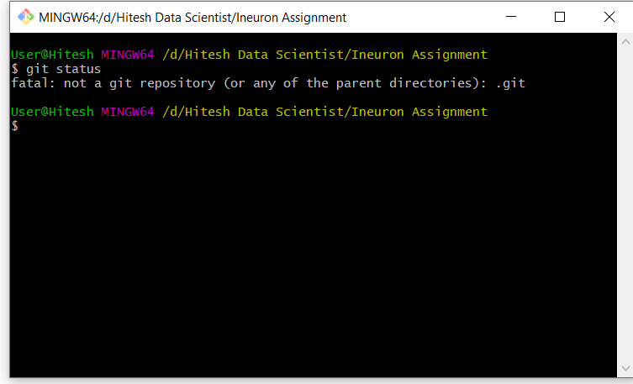

1. **git Init:-**

Converting our current directory into git repository.

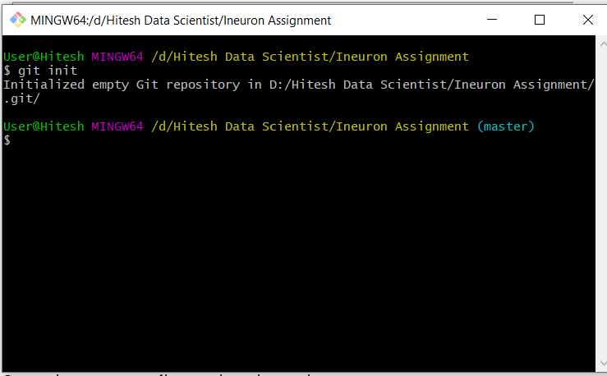

1. **git Status:**

Checking status of current repository.

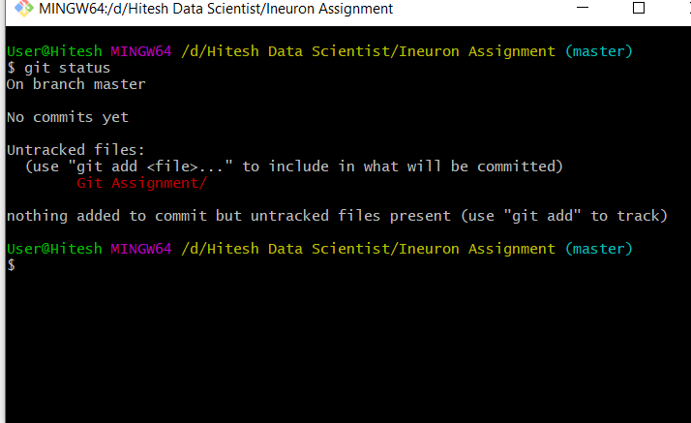

1. **git add .:-**

Adding all tracking file into staging area.

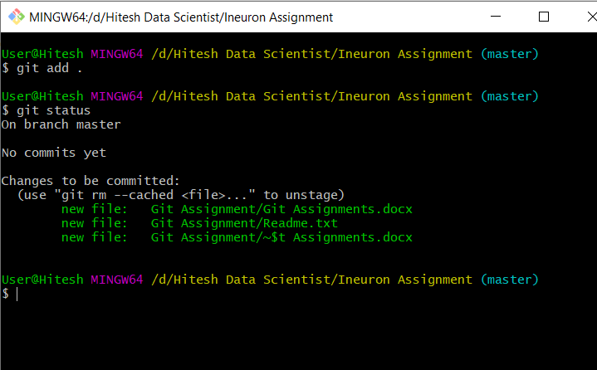

1. **git commit –m :-**

This command is used to commiting all staging file with some valuable message.

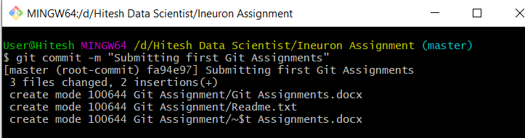

1. **git branch:-**

Chekcing branches in current git repository.

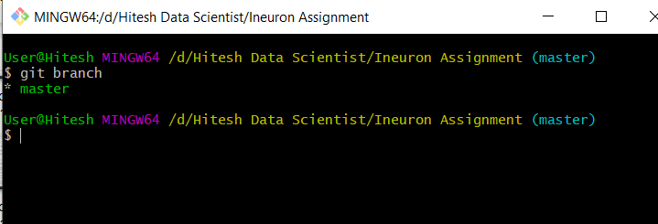

1. **git log:-**

This command is used to displays all of the commits in a repository’s history.

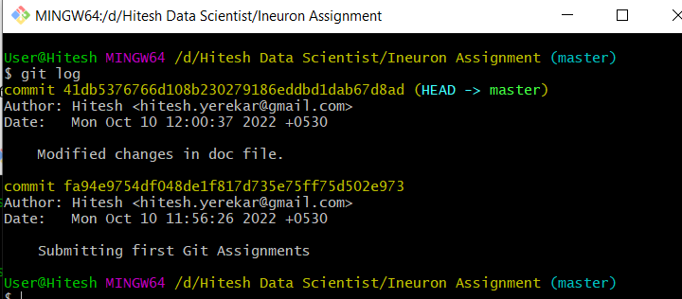

1. **git branch <branch_Name>:-**

This command is used to creating a subbranch in main repository.

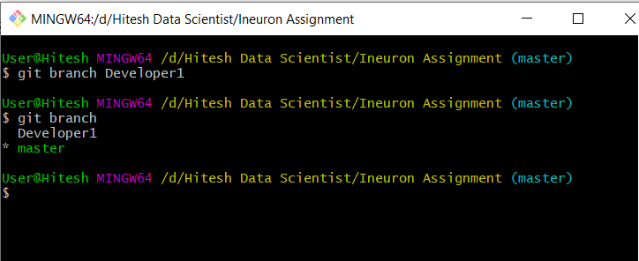

1. **git push:-**

This coomand is used to push all directory file into main github repository.

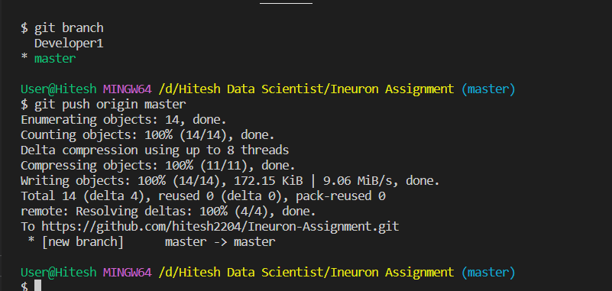

1. **git chekout:-**

This command is used to switch one branch to another branch.

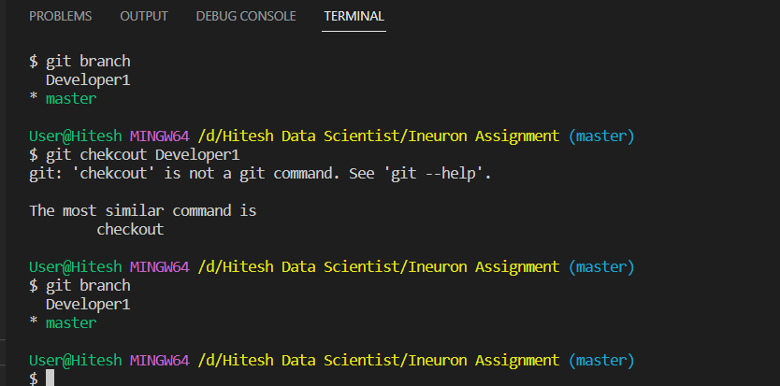

1. **git log –p:-**

This command is used to find out the past commits which helps to see who did what in Git and the repository.

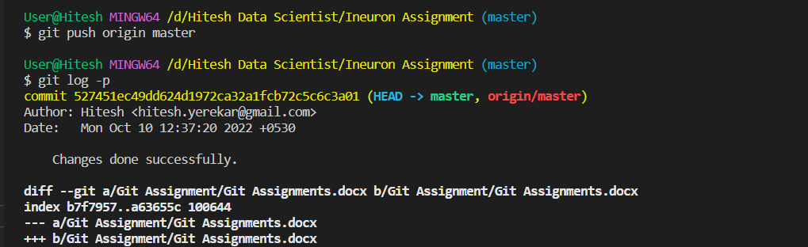

1. **git rm :-**

This command is used to remove file from repository.

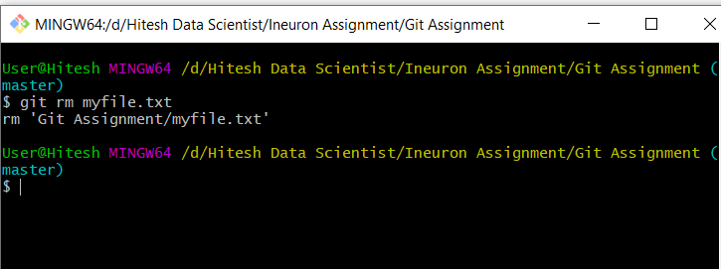

1. **git push<sub_branch>:-**

This command is used to adding any file into sub_branch.

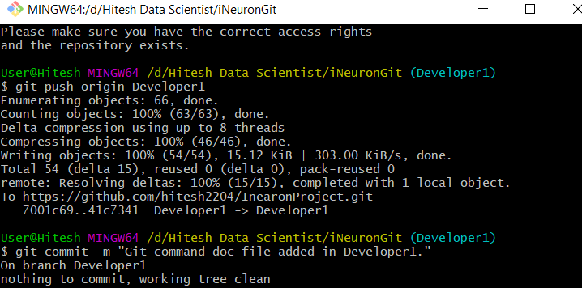

1.  **git merge :-**

This command is used to merge one branch into another single branch.

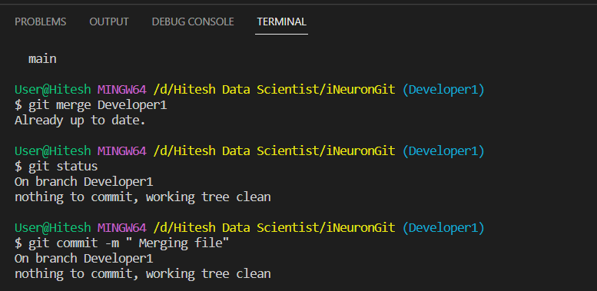

1. **rm –rf .git:-**

This command is used to delete repository forcefully.

